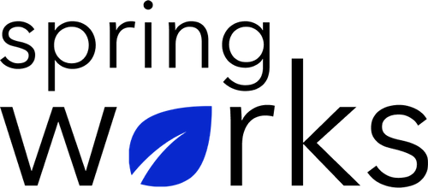
Free Template – Knowledge Management Survey

Use this survey to gain insights into the knowledge department of the organization .

Knowledge management is an essential to ensure good flow of information in an organization. Here is a survey to analyze how your employees feel about the procedure to follow:

Communication (to be added as review instructions):

Your responses to this survey are anonymous. The leaders are committed to analyzing your results and taking action. Please answer this quick survey by <HOUR OF THE DAY> on <DATE>.

Thank you for your time. Your responses will help our organization become a better place to work. If you have any questions about the survey, please contact [insert name of contact person].

Demographic Information:

The following information is requested so that meaningful analysis and comparisons of group results can be made. Please check the circle corresponding to your answer.

Q: Your Gender:

- Male
- Female

Q: Your Department:

- Marketing
- Operations
- Tech
- Accounting
- HR

Q: Company Service:

- Under 1 Year
- 1-2 Year
- 3-5 Year
- 6-10 Year
- 10-15 Year
Knowledge Management Questionnaire

To answer clearly what you think or feel about each item, please follow these steps:

- Read each item fully before you start to mark your answer.
- Pick the one answer which most nearly says what you think or how you feel.
- While completing the questions, be sure to read the special instructions which are included.

Choose the most appropriate answer:

Q: My company focuses on maintaining an efficient knowledge management system:

- Strongly agree
- Agree
- Neutral
- Disagree
- Strongly disagree

Q: The knowledge management department withholds trustworthy and correct information:

- Strongly agree
- Agree
- Neutral
- Disagree
- Strongly disagree

Q: The employees are allowed to access this system whenever required:

- Yes
- No
- Often
- Sometimes

Q: Company ensures open communication and flow of info for all employees:

- Strongly agree
- Agree
- Neutral
- Disagree
- Strongly disagree

Q: Employees participate in managing this system as equally as the organization:

- Strongly agree
- Agree
- Neutral
- Disagree
- Strongly disagree

Q: Employees are allowed to express their opinions without any fear:

- Strongly agree
- Agree
- Neutral
- Disagree
- Strongly disagree

Q: My opinions are acted upon and not simply ignored:

- Strongly agree
- Agree
- Neutral
- Disagree
- Strongly disagree

Q. My organization encourages us to access the knowledge management department to its best advantage:

- Strongly agree
- Agree
- Neutral
- Disagree
- Strongly disagree

Q: Overall, I am satisfied with the focus my organization has on knowledge management:

- Yes
- No
- Can do better

Q: Any area(s) where the knowledge management system of the organization can improve?

i.
ii.
iii.

